Teams:
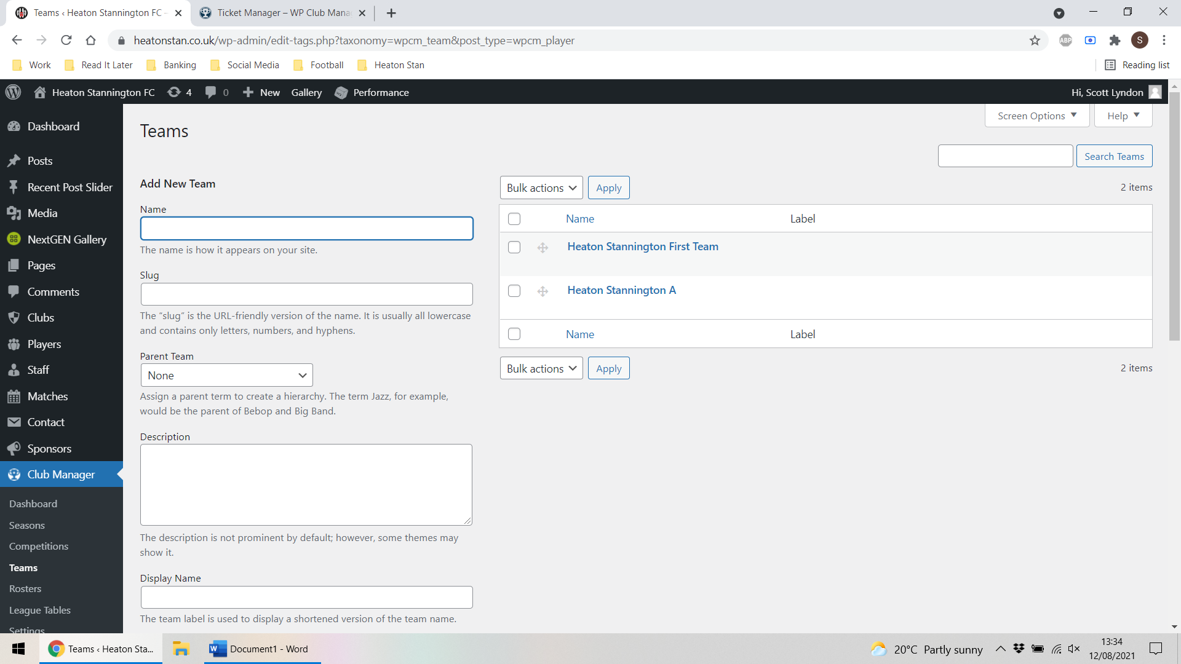
Seasons
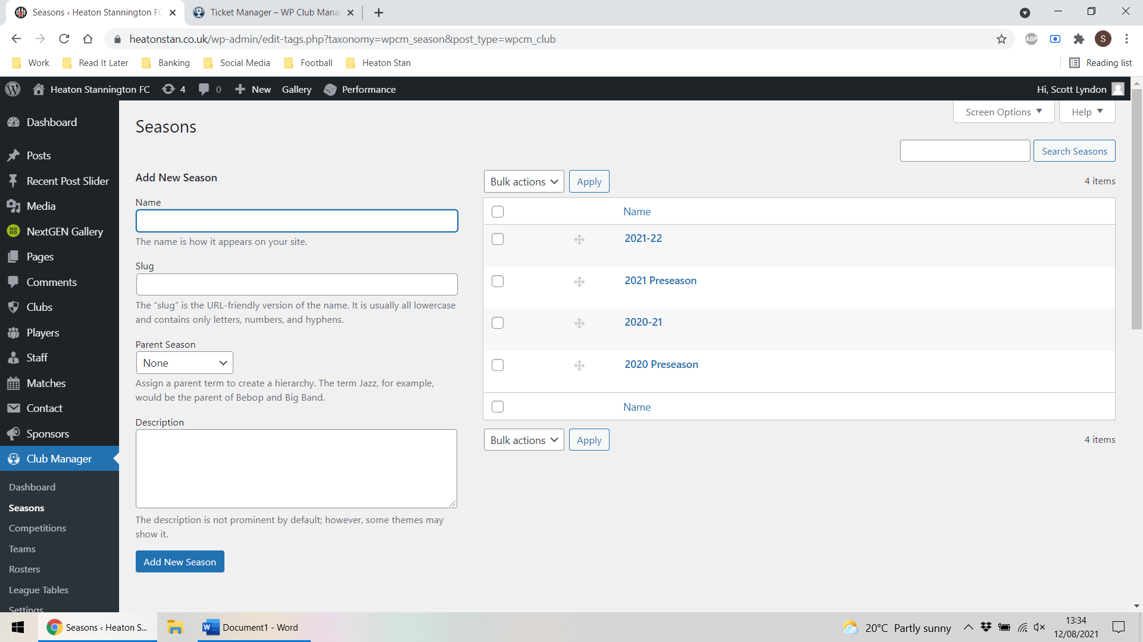
Matches – filtered by “Heaton Stannington A” – the team with issues:
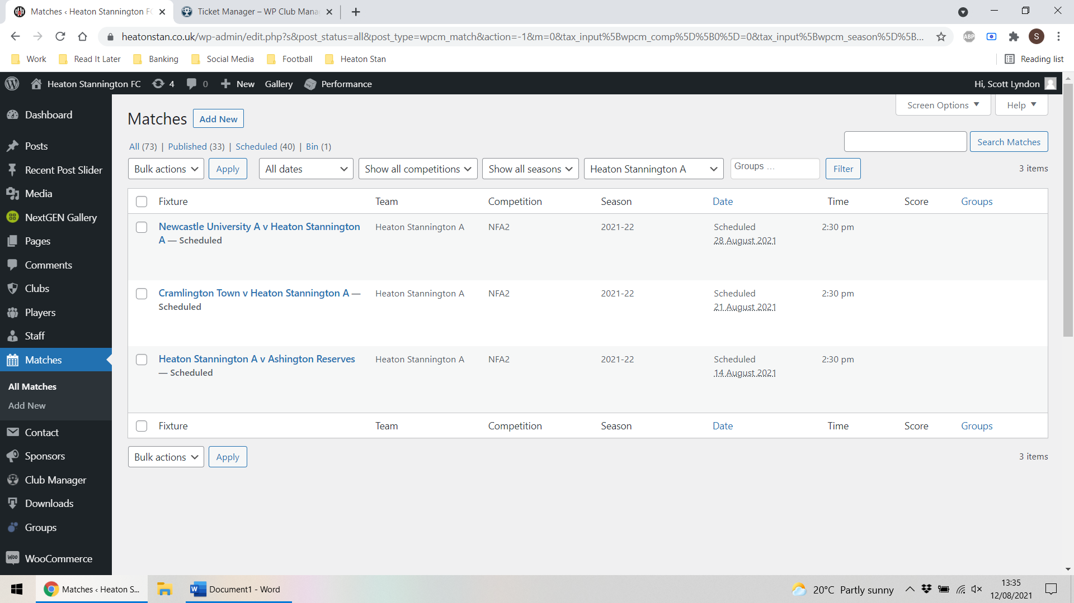
And for comparison – fixtures for “Heaton Stannington First Team” which is working:
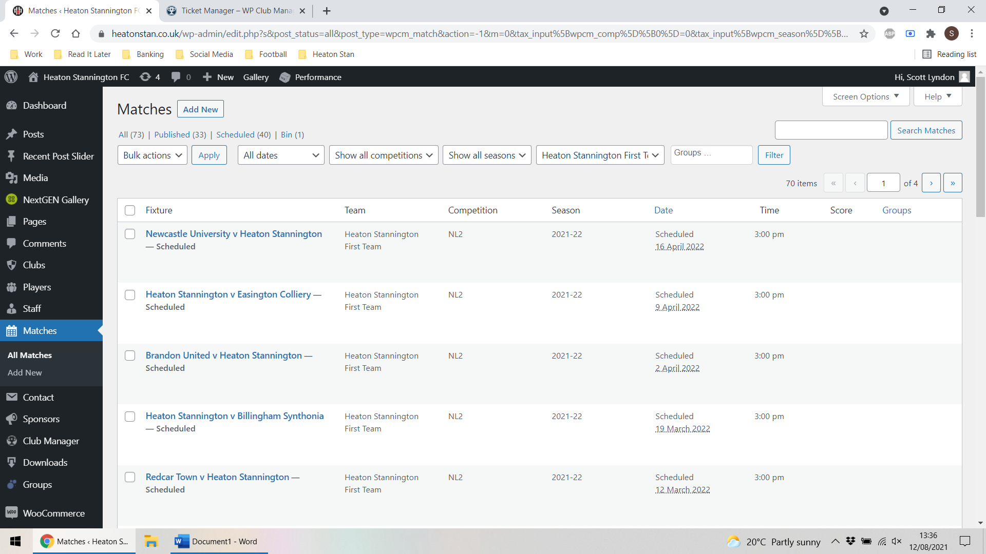

Short code used on “Heaton Stannington First Team” page which shows both results and fixtures:
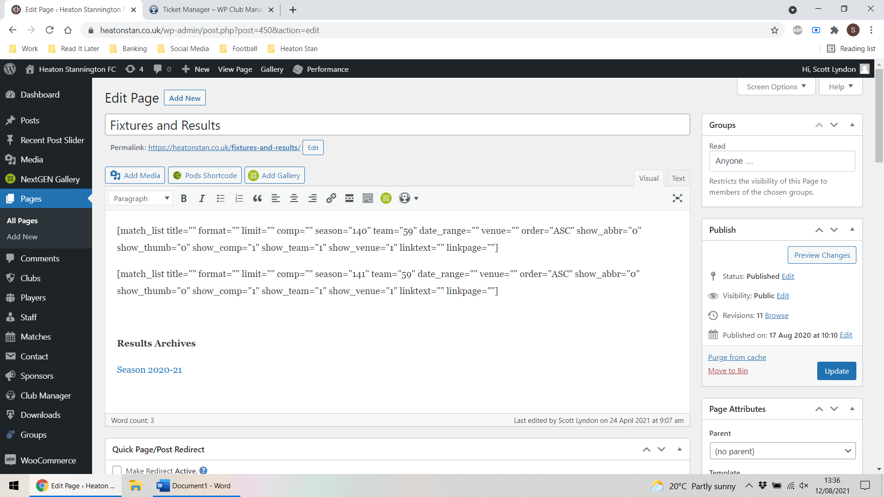
Short code used on “Heaton Stannington A” page which will only show something if it is a result:
